Shell Scripting

- The basic concept of a shell script is a list of commands, which are listed in the order of execution.

- The comment in the shell script is done by using ‘#’ symbol.

- The shell script file has extension ‘.sh’

- Before writing the script, we need to alert the system that a shell script is being started. This is done using the ‘shebang’(#!) construct.

- This tells the system that the commands that follow are to be executed by the Bourne shell.

- The #! syntax used in scripts to indicate an interpreter for execution under UNIX / Linux operating systems.

- Most Linux shell and perl / python script starts with the following line:
#!/bin/bash
OR
#!/usr/bin/perl
OR
#!/usr/bin/python

- If you do not specify an interpreter line, the default is usually the /bin/sh. But, it is recommended that you set #!/bin/bash line.

- For a system boot script, use /bin/sh:
e.g. #!/bin/sh

- ‘sh’ is the standard command interpreter for the system. The current version of sh is in the process of being changed to conform with the POSIX 1003.2 and 1003.2a specifications for the shell.

Variables:
A variable is a character string to which we assign a value.
The value assigned could be a number, text, filename, device, or any other type of data.

Variable Names:
Variable name only contains a-z, A-Z, 0-9 and _ (underscore).
By convention, Unix shell variables will have their names in UPPERCASE.

e.g. _HARSHAL
TOKEN_A
VAR_1
VAR_2
To access the value stored in a variable, prefix its name with the dollar sign ($)
e.g. MYVAR=“Harshal”
echo $MYVAR

‘echo’ is a keyword to print the message or the contents of the variables (like printf).

Read-Only Variables:
Shell provides a way to mark variables as read-only by using the read-only command.
After a variable is marked read-only, its value cannot be changed.

e.g. NAME=“Harshal”
readonly NAME
NAME=“Gunda”

Unsetting the Variables:
Unsetting or deleting a variable directs the shell to remove the variable from the list of variables that it tracks.
Once you unset a variable, you cannot access the stored value in the variable.

Syntax: unset variable_name

e.g. NAME= “Harshal”
unset NAME

We cannot unset the read-only variables.
e.g. NAME= “Harshal”
readonly NAME
unset NAME

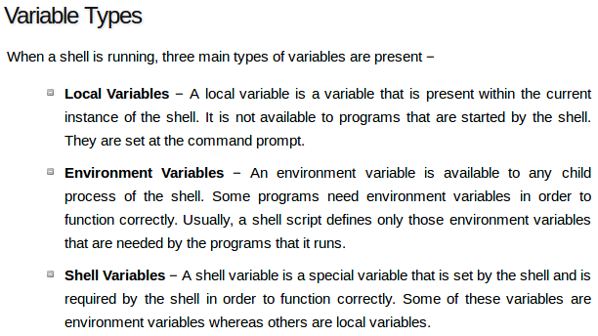

Special Variables in Shell Scripting:

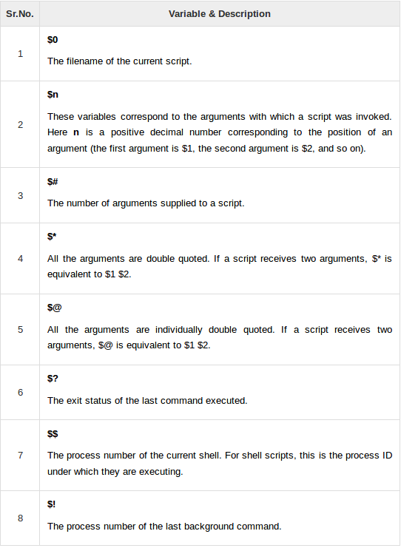
e.g. echo $$
echo $n

Array in Shell Scripting:

Following method is used to create the array.
Syntax: array_name[index]=value

e.g. CUE_ARR[0]=“Harshal”
CUE_ARR[1]=“Mahesh”
CUE_ARR[2]=“Sumit”
CUE_ARR[3]=“Amey”

- If you are using the ‘ksh’ shell, here is the syntax of array initialization −
set -A array_name value1 value2 ... valuen

- If you are using the ‘bash’ shell, here is the syntax of array initialization −
array_name=(value1 ... valuen)

Arithmetic Operators:

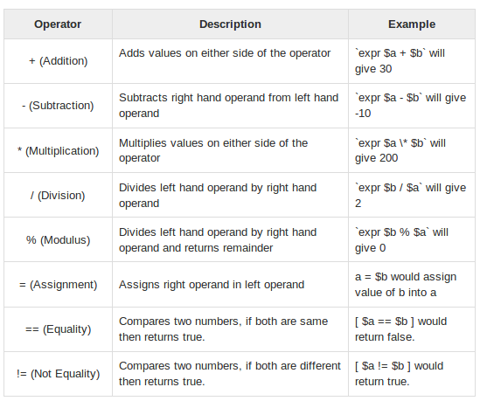

- All the arithmetical calculations are done using long integers.

- It is very important to understand that all the conditional expressions should be inside square braces with spaces around them like [$a == $b]

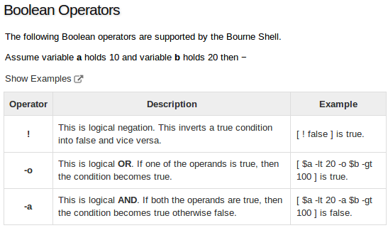

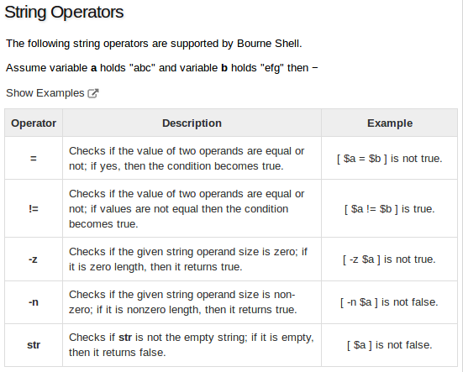

Shell Substitutions:
The shell performs substitution when it encounters an expression that contains one or more special characters.
Using ‘-e’ option in echo statement, we can enables the interpretation of backslash escapes.

e.g. echo “Name: \t Harshal”

Output will be, Name: \t Harshal

Now, with ‘-e’ option the output will be,
Name: Harshal

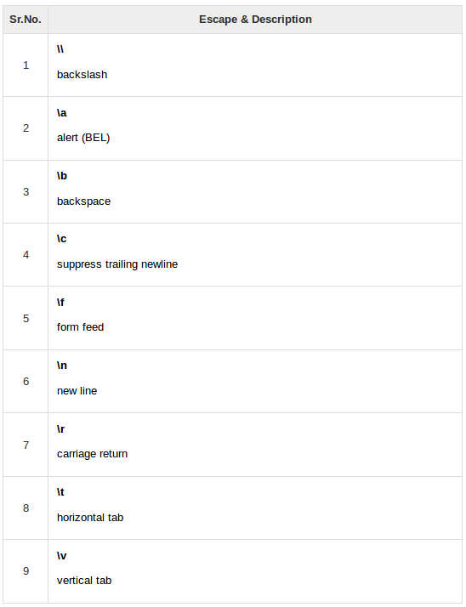
1) Command Substitution:
- The command substitution is performed when a command is given as − `command`

- When performing the command substitution make sure that you use the backquote, not the single quote character.

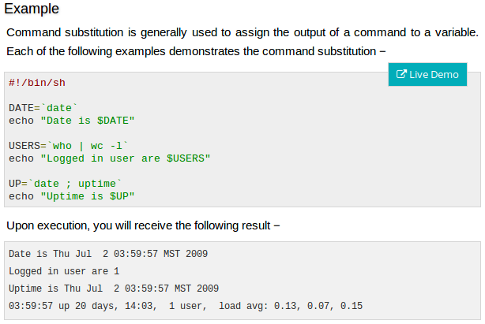

2) Variable Substitution:
Variable substitution enables the shell programmer to manipulate the value of a variable based on its state.

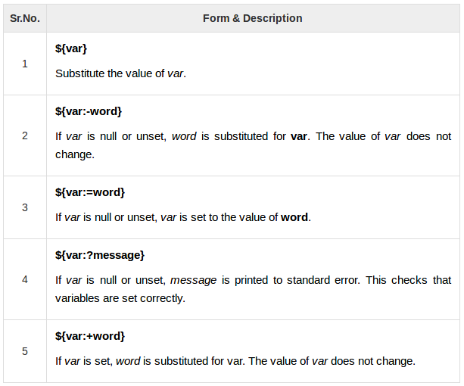

Metacharacters:
Unix Shell provides various metacharacters which have special meaning while using them in any Shell Script and causes termination of a word unless quoted.
Here is a list of most of the shell special characters (also called metacharacters) −

* ? [ ] ' " \ $ ; & ( ) | ^ < > new-line space tab

A character may be quoted (i.e., made to stand for itself) by preceding it with a \.

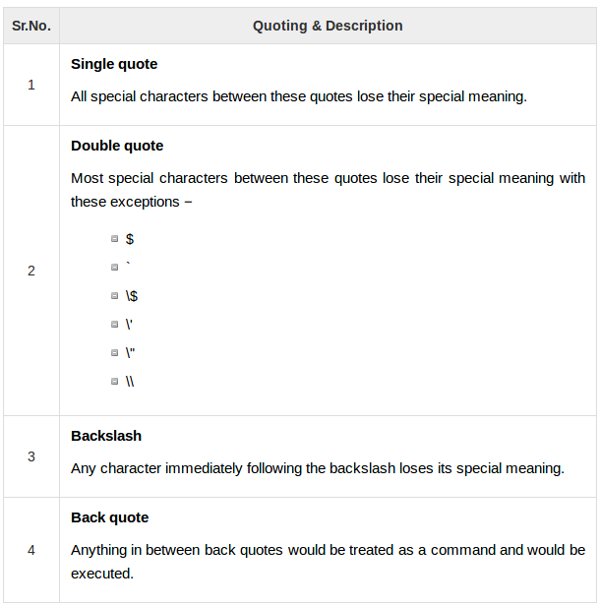

Creating functions in shell scripting:

Syntax:

function_name(){
list of commands
}

For example,

#!/bin/sh

#define the function
fun () {
echo “Hello, World”
}

#invoke/call the function
fun

- We can pass the parameters to the function.
- We can also make nested function calls.

